1. Introduction to PC Hardware

a. RAM, ROM, Motherboard, SMPS, Processor

## Central Processing Unit (CPU)

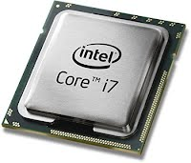

"The CPU or processor is the "brain" of the computer. It performs all the operations that the computer does, from simple encoding of text to complex rendering of video. So, the faster the speed of your processor, the faster your computer will run." The most well-known processors are made by Intel and include the Celeron, Pentium, and Core (i3,i5,i7, etc).

**Random Access Memory**

[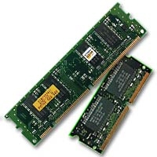](https://sites.google.com/a/arlington.k12.ma.us/all-about-computers/cpu-ram-hard-disk-motherboard/ram-ch.jpg?attredirects=0)

"Usually referred to as 'memory', RAM is second to the CPU in determining your computer's performance. It temporarily stores your computer's activities until they are transferred and stored permanently in your hard disk when you shut down or restart." RAM is measured in gigabytes (GB), and the average modern computer has between 4-8 GB of RAM. The more RAM your computer has, the faster it runs (up to a point).

## Hard Disk Drive

|  |  |
| --- | --- |
| [https://sites.google.com/a/arlington.k12.ma.us/all-about-computers/_/rsrc/1495389948259/cpu-ram-hard-disk-motherboard/81rt4.jpg?height=148&width=200](https://sites.google.com/a/arlington.k12.ma.us/all-about-computers/cpu-ram-hard-disk-motherboard/81rt4.jpg?attredirects=0) | [https://sites.google.com/a/arlington.k12.ma.us/all-about-computers/_/rsrc/1495389948259/cpu-ram-hard-disk-motherboard/1200px-Laptop-hard-drive-exposed.jpg?height=153&width=200](https://sites.google.com/a/arlington.k12.ma.us/all-about-computers/cpu-ram-hard-disk-motherboard/1200px-Laptop-hard-drive-exposed.jpg?attredirects=0) |

"The hard disk drive, more commonly known as the hard drive or hard disk, is where all data and programs are stored in your computer permanently, unless you delete them. Generally speaking, a hard disk with a higher capacity is always better."

## Motherboard

[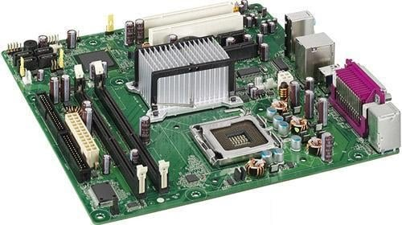](https://sites.google.com/a/arlington.k12.ma.us/all-about-computers/cpu-ram-hard-disk-motherboard/id205257_1.jpg?attredirects=0)

The motherboard is a large circuit board that connects all the parts of the computer, including the hard disk drive, CPU, and RAM. The motherboard is like the nervous system in your body - it distributes signals to and from all the parts and helps coordinate their activities.

**Switched-Mode Power Supply (SMPS)**

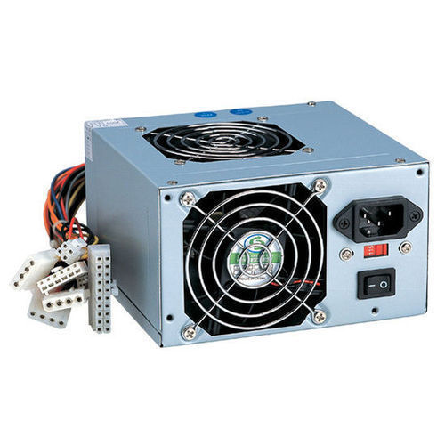

A switched-mode power supply (SMPS) is an electronic circuit that converts power using switching devices that are turned on and off at high frequencies, and storage components such as inductors or capacitors to supply power when the switching device is in its non-conduction state. Switching power supplies have high efficiency and are widely used in a variety of electronic equipment, including computers and other sensitive equipment requiring stable and efficient power supply.